**Bank Marketing Analysis**

*Dissertation submitted in fulfilment of the requirements for the Degree of*

**BACHELOR OF TECHNOLOGY**

**in**

**COMPUTER SCIENCE AND ENGINEERING**

By

**Srujan Kumar Reddy**

**12111003**

Supervisor

**MR. VED PRAKASH CHAUBEY**



**School of Computer Science and Engineering**

Lovely Professional University

Phagwara, Punjab (India)

Month - April Year - 2024

@ Copyright LOVELY PROFESSIONAL UNIVERSITY, Punjab (INDIA)

ALL RIGHTS RESERVED

**DECLARATION STATEMENT**

I hereby declare that the research work reported in the dissertation/dissertation proposal entitled "BANK MARKETING ANALYSIS” in partial fulfillment of the requirement for the award of Degree a Bachelor of Technology in Computer Science and Engineering at Lovely Professional University, Phagwara, Punjab is an authentic work carried out under supervision of my research supervisor Mr./Mrs. Research Guide’s Name. I have not submitted this work elsewhere for any degree or diploma.

I understand that the work presented herewith is in direct compliance with Lovely Professional University’s Policy on plagiarism, intellectual property rights, and the highest standards of moral and ethical conduct. Therefore, to the best of my knowledge, the content of this dissertation represents an authentic and honest research effort conducted, in its entirety, by me. I am fully responsible for the contents of my dissertation work.

**Srujan Kumar Reddy**

**Reg.No 12111003**

**SUPERVISOR’S CERTIFICATE (16 bold)**

This is to certify that the work reported in the B. Tech Dissertation/dissertation proposal entitled “**BANK MARKETING ANALYSIS”** submitted by **Srujan Kumar Reddy**

at **Lovely Professional University, Phagwara, India** is a Bonafede record of his / her original work carried out under my supervision. This work has not been submitted elsewhere for any other degree.

Signature of Supervisor

(Name of Supervisor)

**Date:**

**Counter Signed by:**

1. **Concerned HOD:**

HoD’s Signature: ________________

HoD Name: ____________________

Date: ___________________

1. **Neutral Examiners:**

**External Examiner**

Signature: _______________

Name: __________________

Affiliation: ______________

Date: ___________________

**Internal Examiner**

Signature: _______________

Name: __________________

Date: ___________________

**TABLE OF CONTENTS**

**CONTENTS PAGE NO.**

Cover Page 1

Declaration Statement 2

Supervisor’s Certificate 3

Table of Contents 4 - 6

List of Equations 7

**CHAPTER 1: INTRODUCTION** 8 - 9

* 1. **Abstract**

**1.2 Problem Statement**

**1.3 Objectives**

**CHAPTER 2: REVIEW OF LITERATURE** 9

**CHAPTER 3: SYSTEM REQUIREMENTS SPECIFICATION** 10 - 11

**3.1 Hardware requirements**

**3.2 Software specification**

**3.3 Software requirements**

**3.3.1 Anaconda distribution**

**3.3.2 Python Libraries**

**CHAPTER 4 – DATA COLLECTION FOR BANK MARKETING** 11 **-**12 **ANALYSIS AND IMPORTING NECCESITIES**

**4.1 Gathering Data**

**4.1.1 Open Sources**

**4.1.2 Collection by Individuals**

**4.1.3 Crowd Sourcing**

**4.2 Importing Necessities**

**CHAPTER 5 : DATA CLEANING FOR BANK MARKETING** 12 **ANALYSIS**

# DATA CLEANING

**CHAPTER 6: EXPLORATORY DATA ANALYSIS FOR BANK** 13 –20 **MARKETING ANALYSIS**

# 6.1 UNIVARIATE ANALYSIS

**6.1.1 Categorical unordered univariate analysis**

**6.1.2 Categorical ordered univariate analysis**

**6.2 Bivariate Analysis**

**6.2.1 Numeric - numeric analysis**

**6.2.2 Numerical - Categorical**

**6.2.3 Categorical - Categorical variable**

**6.4 Multivariate analysis**

**6.5 STATISTICAL ANALYSIS**

**CHAPTER 7 : DATA PREPARATION FOR BANK MARKETING** 20-22 **ANALYSIS**

**7.1 Predicting response variable**

**7.2 Importing libraries**

**7.3 Encoding categorical variables**

**7.4 Standard scaling for the model**

**7.5 Defining a preprocessor (using the ColumnTransformer class in the scikit-learn library)**

**7.6 fit_transform method**

**7.7 Spliting the model into training and testing data sets**

**CHAPTER 8 : PREDICTION USING LOGISTIC REGRESSION** 23 - 25

**8.1 fitting the model and predicting**

**8.2 precision score and recall score**

**8.3 Evaluating the model on Logistic regression**

**8.4 AUC – ROC**

**CHAPTER9:PREDICTINGUSING RANDOMFORESTCLASSIFIER**25**-**28

**9.1 Fitting the model and predicting on RandomForestClassifier**

**9.2 Evaluating the model on RandomForestClassifier**

**CHAPTER 10 : RESULTS** 33

**CHAPTER 11 : CONCLUSION** 35

**REFERENCES** 38

**APPENDIX** 38-39

**CHAPTER1: INTRODUCTION**

**1.1 Abstract**

The Bank Marketing Analysis is a study that analyzes a Portuguese bank's telemarketing campaign. The campaign aimed to promote term deposits among its clients. The analysis uses data collected over a period of 2 years (2008-2010), and it contains 41,188 samples with 20 features, including demographic, economic, and other relevant client information.The main goal of the analysis is to identify the factors that affect a client's decision to subscribe to a term deposit. In addition, the study aims to build a predictive model that can help the bank to target clients who are more likely to subscribe to a term deposit, thus improving the effectiveness of the campaign and reducing marketing costs.The analysis involves various stages, including data cleaning, data exploration, feature engineering, and machine learning. During the data exploration stage, the study identifies that the dataset is imbalanced, with only 11.7% of the samples subscribing to a term deposit. This information is used to adjust the performance metrics during the machine learning stage.The study uses various machine learning algorithms, including logistic regression, decision tree, and random forest, to build predictive models. The models' performance is evaluated using various metrics, such as accuracy, precision, recall, F1-score, and area under the ROC curve (AUC-ROC). The Bank Marketing Analysis provides insights into the factors that influence a client's decision to subscribe to a term deposit and highlights the importance of building predictive models to improve the effectiveness of marketing campaigns.

**1.2 Problem statement**

The problem statement of the Bank Marketing Analysis is to identify the factors that influence a client's decision to subscribe to a term deposit and to build a predictive model that can help the bank to target clients who are more likely to subscribe to a term deposit. The objective is to improve the effectiveness of the bank's telemarketing campaign and reduce marketing costs by targeting the right clients. Additionally, the study aims to understand the underlying patterns in the data and provide insights that can inform the bank's marketing strategy.

**1.3 Objectives**

The objectives of the Bank Marketing Analysis project can be summarized as follows:

* Understand the data: Explore and analyze the data to gain insights into the underlying patterns and relationships in the data.
* Identify factors that influence clients' subscription: Identify the key factors that influence clients' decision to subscribe to a term deposit.
* Build a predictive model: Build a predictive model that can help the bank to target clients who are more likely to subscribe to a term deposit.
* Evaluate the model: Evaluate the performance of the predictive model using appropriate metrics such as accuracy, precision, recall, and F1-score.
* Provide insights: Provide insights that can inform the bank's marketing strategy and improve the effectiveness of the telemarketing campaign.
* Optimize marketing costs: Reduce marketing costs by targeting the right clients and increasing the conversion rate of the telemarketing campaign.

**CHAPTER 2: REVIEW OF LITERATURE**

The Bank Marketing Analysis project has been widely researched in the literature, and several studies have been conducted to analyze the factors that influence clients' decision to subscribe to a term depositOne of the commonly cited studies is the paper by Moro et al. (2014) titled "Data Mining Reveals the Factors Influencing the Subscription of Term Deposits". The authors used a dataset from a Portuguese banking institution to build predictive models using several machine learning algorithms, including decision trees, random forests, and logistic regression. The study identified age, job, marital status, education, and contact type as the key factors that influence clients' subscriptions to a term deposit. Another study by Zaki et al. (2016) titled "A Comparative Study of Data Mining Algorithms for Predicting Bank Term Deposit Subscription" compared the performance of several data mining algorithms, including decision trees, neural networks, and k-nearest neighbors, in predicting clients' subscription to a term deposit. The study used a dataset from a Tunisian bank and found that decision trees outperformed other algorithms in terms of accuracy and F1 score. Several studies have focused on feature selection and feature engineering to improve the performance of predictive models in bank marketing analysis. For example, the study by Liu et al. (2019) titled "Feature Selection for Bank Term Deposit Subscription Prediction: A Comparative Study" compared the performance of several feature selection methods, including correlation-based feature selection, mutual information-based feature selection, and wrapper-based feature selection, in predicting clients' subscription to a term deposit. The study found that mutual information-based feature selection outperformed other methods in terms of accuracy and F1 score.

**CHAPTER3: SYSTEM REQUIREMENTS SPECIFICATION**

This chapter involves both the software and hardware requirements needed for the project and detailed explanation of the specifications.

**3.1 Hardware requirements**

→ A PC with Windows/Linux OS

→ Processor with 1.7-2.4gHz speed

→ Minimum of 4Gb RAM (8Gb recommended)

→ At least 2Gb of GPU memory (dedicated or integrated)

**3.2 Software Specification**

→ Text Editor (VS-code/Web-storm)

→ Anaconda distribution package with Jupter Notebook

→ Required python Libraries

**3.3 Software Requirements**

**3.3.1 Anaconda distribution**:

Anaconda is a free and open-source distribution of the Python programming languages for scientific computing (data science, machine learning applications. large-scale data processing, predictive analytics, etc.), that aims to simplify package management systems and deployment. Package versions are managed by the package management system conda. The anaconda distribution includes data-science packages suitable for Windows, Linux and MacOS.3

**3.3.2 Python libraries**:

For the computation and analysis, we need certain Python libraries which are used to perform analytics. Packages such as SKlearn, Numpy, pandas, matplotlib, Flask framework, etc are needed.

**SKlearn**:

It features various classification, regression and clustering algorithms including support vector machines, random forests, gradient boosting, k-means and DBSCAN, and is designed to interoperate with the Python numerical and scientific libraries NumPy and SciPy.

**NumPy**:

NumPy is a general-purpose array-processing package. It provides a high-performance multidimensional array object, and tools for working with these arrays. It is the fundamental package for scientific computing with Python. Pandas: Pandas is one of the most widely used python libraries in data science. It provides high-performance, easy to use structures and data analysis tools. Unlike NumPy library which provides objects for multi- dimensional arrays, Pandas provides in-memory 2d table object called Data frame.

**Pandas:** Pandas is a Python library used for working with data sets. It has functions for analyzing, cleaning, exploring, and manipulating data. Pandas allows us to analyze big data and make conclusions based on statistical theories. Pandas can clean messy data sets, and make them readable and relevant.

**CHAPTER 4 - DATA COLLECTION FOR BANK MARKETING ANALYSIS AND IMPORTING NECESSITIES**

**4.1 Gathering data**

The following are the three ways that can be utilized to gather data for our model.

**4.1.1 Open Sources** – This data is readily available in the form of structured data (rows and columns) and can be downloaded from sites like Kaggle, UCI-ML-Repository, and Open Government Data.

**4.1.2 Collection by Individuals** – Often it happens that in some cases, data is not available so the team gathers data using tools like we scrapper or go out and gather data for themselves.

**4.1.3 Crowd Sourcing** – In this technique, people like ours help in annotating data for eg. Captcha services.

**4.2 Importing necessities**

We will start by loading some essential libraries needed for the project:

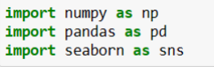

* NumPy is a library for the Python programming language, adding support for large, multi-dimensional arrays and matrices, along with a large collection of high-level mathematical functions to operate on these arrays. We can use it for carrying out various calculations in our project.
* Pandas is a Python library used for working with data sets. It has functions for analyzing, cleaning, exploring, and manipulating data. Pandas allows us to analyze big data and make conclusions based on statistical theories.

Pandas can clean messy data sets, and make them readable and relevant. Pandas gives you answers about the data. Like:

➔ Is there a correlation between two or more columns?

➔ What is average value?

➔ Max value?

➔ Min value?

* Pandas are also able to delete rows that are not relevant, or contains wrong values, like empty or NULL values. This is called cleaning the data. I will be separately covering this section in later chapters.
* Seaborn is a Python data visualization library based on matplotlib. It provides a highlevel interface for drawing attractive and informative statistical graphics.

**CHAPTER 5 - EXPLORATORY DATA CLEANING FOR BANK MARKETING ANALYSIS**

# 5.1 DATA CLEANING

Data cleaning: This is the first step of EDA. We take a raw dataset and eliminate problems which could prevent us from further analysis. Cleaning Data that tends to removing null values, deleting duplicates, removing rows and columns which are not needed for further implementation and not needed for further analysis.

So, I checked all rows and columns for null values and duplicate values in my dataset.

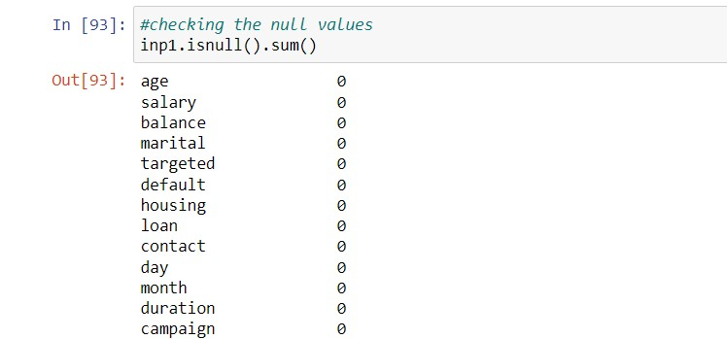

As you can see there are no null values in my dataset. So, we can proceed to further analysis.

**CHAPTER 6 - EXPLORATORY DATA ANALYSIS FOR BANK MARKETING ANALYSIS**

# 6.1 UNIVARIATE ANALYSIS

Univariate EDA deals with exploring and analysing one variable at a time. Statistically, you can represent a variable's distribution using mean, median, or mode. Visually, you can represent it with histograms, boxplots, bar charts, etc.

Two types of univariate analysis are there, They are:

* + 1. **Categorical unordered univariate analysis**

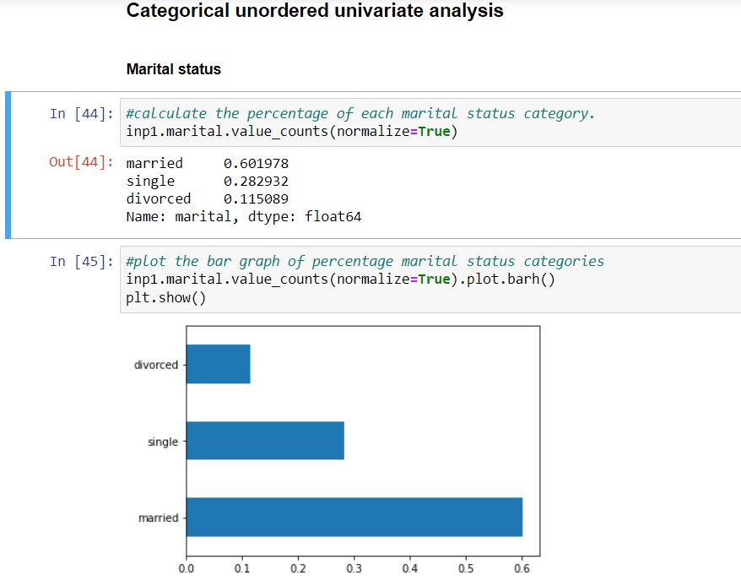

There is only one variable that is marital and it is not dealing with any cause or relationship. The description of patterns found in this type of data can be made by drawing conclusions using central tendency measures (mean, median and mode), dispersion or spread of data ( range, minimum, maximum, quartiles, variance and standard deviation) and by using frequency distribution tables, histograms, piecharts, frequency polygon and bar charts.

**6.1.2Categoricalorderedunivariateanalysis**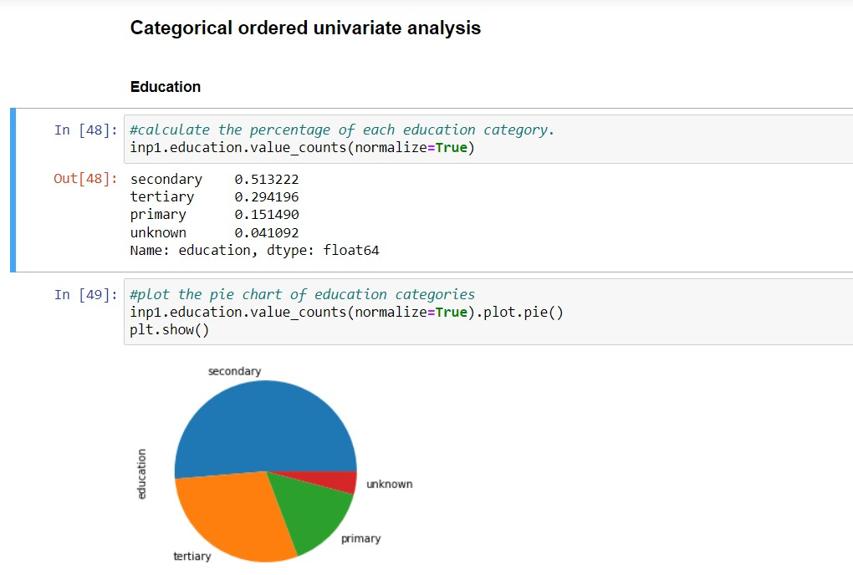

# 6.2 BIVARIATE ANALYSIS

**Bivariate analysis** explore the possible relationship between two variables’ variability. In view of “**exploratory**” focus of EDA, we should refrain from infering based on bivariate analysis.

There are three types:

**6.2.1 Numeric- numeric analysis**

There are three ways to analyse the numeric- numeric data types simultaneously.

* **Scatter plot**: describes the pattern that how one variable is varying with other variable.
* **Correlation matrix:** to describe the linearity of two numeric variables.
* **Pair plot:** group of scatter plots of all numeric variables in the data frame.

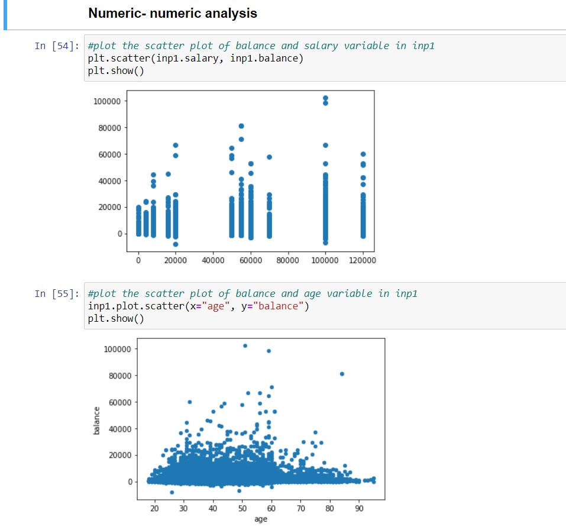

Here, the relationship is visible from the table that age and balance are directly proportional to each other and thus related because as the age increases, the balance are decreasing. Thus bivariate data analysis involves comparisons, relationships, causes and explanations. These variables are often plotted on X and Y axis on the graph for better understanding of data and one of these variables is independent while the other is dependent

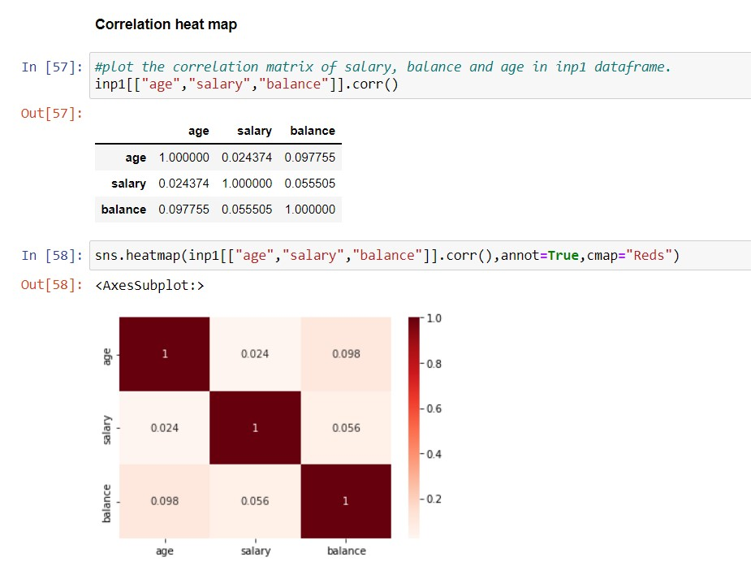

# 6.2.2 Numerical – Categorical variable

# 6.2.3 Categorical - Categorical variable

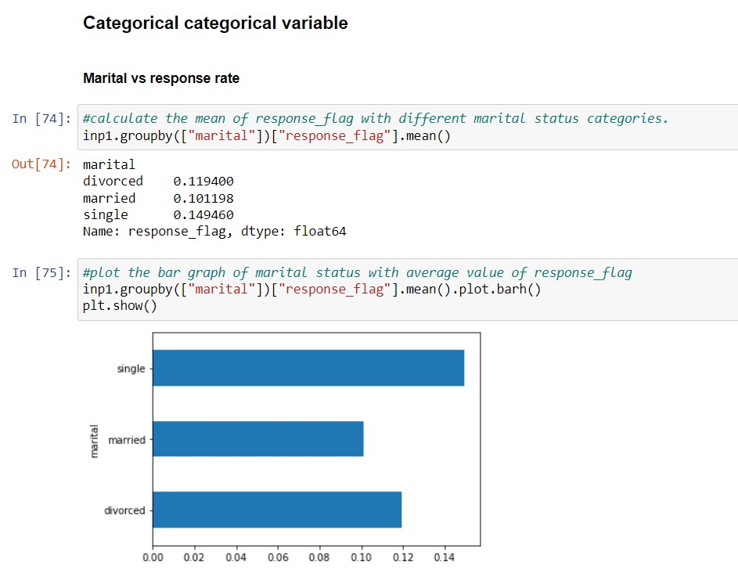6.4 Multivariate analysis

The objective of multivariate EDA is to examine and explore more than two variables at a time. In this case, you will analyse four variables

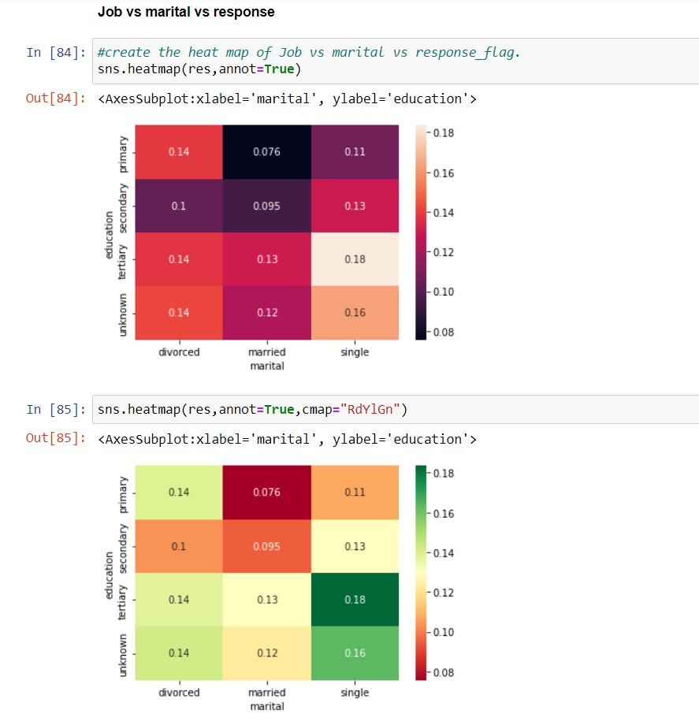

When the data involves three or more variables, it is categorize under multivariate. Example of this type of data is suppose an education wants to compare the marital status of the people. It is similar to bivariate but contains more than one dependent variable. The ways to perform analysis on this data depends on the goals to be achieved. Some of the techniques are regression analysis, path analysis, factor analysis and multivariate analysis of variance.

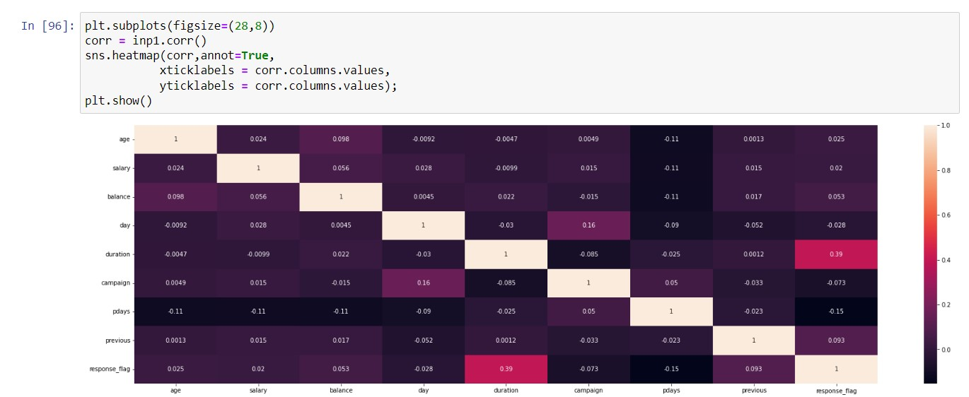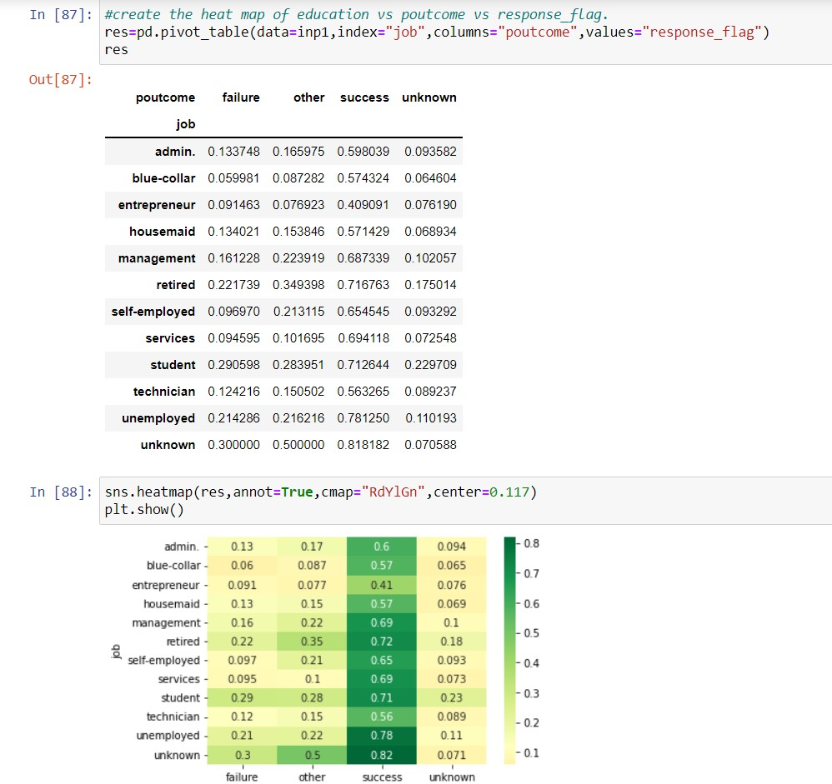

**6.5 STATISTICAL ANALYSIS**

Statistical analysis is done on data sets, and the analysis process can create different output types from the input data. For example, the process can give summarized data, derive key values from the input, present input data characteristics, prove a null hypothesis, etc. The output type and format vary with the analysis method used.

The two main types are [**descriptive statistics**](https://www.wallstreetmojo.com/descriptive-statistics/) and [**inferential statistics**](https://www.wallstreetmojo.com/inferential-statistics/).

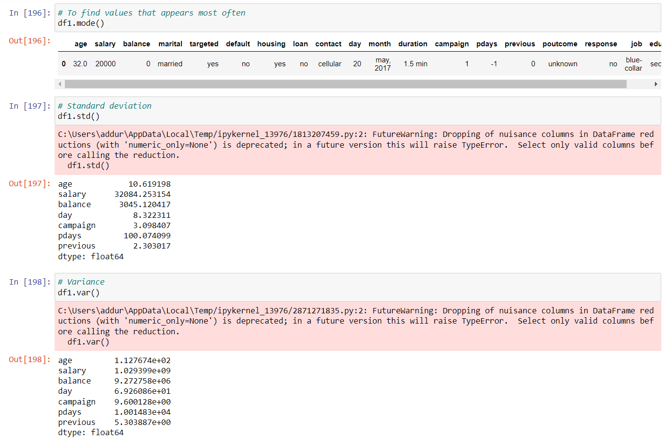

It is one of the simplest and most popular analysis methods easy to apply to data. The mean is the average value of data used in research. In [statistics](https://www.wallstreetmojo.com/statistics/), the term “[mean](https://www.wallstreetmojo.com/mean-formula/)” is commonly used to indicate average. It is calculated by adding the data values and dividing them by the total number of data points. Though it is a common method, it is advised to have other methods supporting it for effective decision-making.

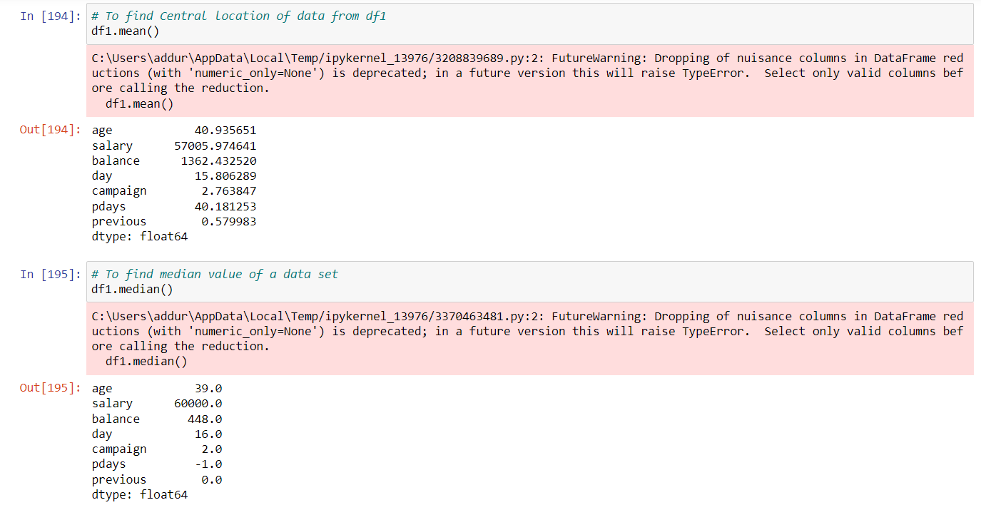

[Standard deviation](https://www.wallstreetmojo.com/standard-deviation-formula/) is a common statistical analysis tool to determine the deviation of a set of values from the mean value. The standard deviation value will be low if the deviation from the mean is small and vice versa.

An example of hypothesis testing is setting up a test to check if a new medicine works on a disease in a more efficient manner. Null Hypothesis The null hypothesis is a concise mathematical statement that is used to indicate that there is no difference between two possibilities

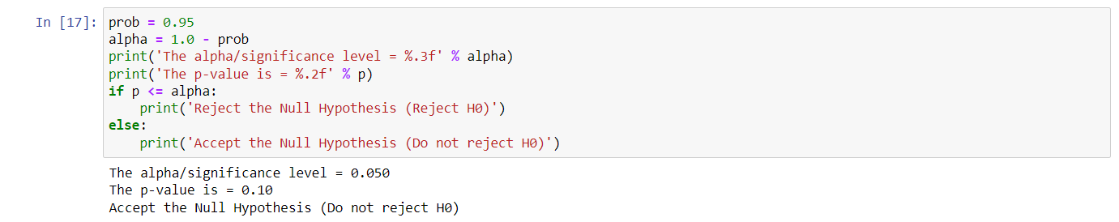

**CHAPTER 7 - DATA PREPARATION FOR BANK MARKETING ANALYSIS**

**Predictions**

* 1. **Predicting response variable(yes/no)**

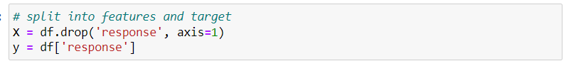

Create X and y varibles then,train and test sets(70-30 or 80-20).Train your model on training set(i.e. learn the coefficients) ,atlast evaluate the model(training set, test set).

So, we will take response variable as y(dependent variable) and remaining variables as X.

* 1. **Importing libraries**

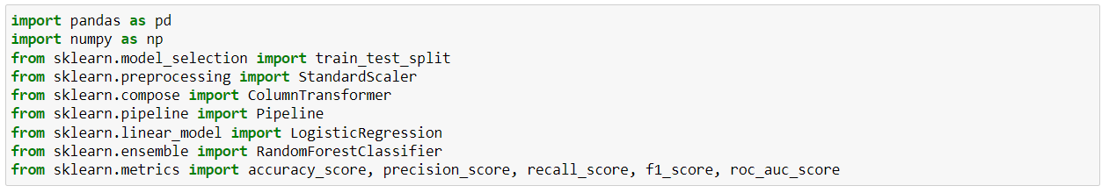

* 1. **Encoding categorical variables**



We have to change categorical variables to numerical variables. We are converting the data in mentioned columns as 0 or 1.

The code snippet provided encodes categorical variables in a pandas DataFrame using the `pd.get_dummies()` method. The method takes in a DataFrame and a list of columns to encode as categorical variables. In this case, the list of columns is `['marital', 'job', 'education', 'targeted', 'default', 'housing', 'loan', 'contact']`.

For each column, the method creates a new set of binary columns, with one column for each unique value in the original column. For example, if the original column was `marital` and it had three unique values (`single`, `married`, and `divorced`), the method would create three new columns (`marital_single`, `marital_married`, and `marital_divorced`). The value in each new column is 1 if the original row had that value in the original column, and 0 otherwise.

The `drop_first=True` parameter drops one of the binary columns for each categorical variable to avoid multicollinearity. This means that if there are n unique values for a categorical variable, only n-1 binary columns will be created.

In summary, the code snippet encodes categorical variables as binary columns using the `pd.get_dummies()` method.

* 1. **Standard scaling for the model**



The mentioned code snippet defines a Pipeline object named 'num_transformer' which contains a single step named 'scaler'. This step applies the StandardScaler method to the input data. The StandardScaler method scales the data to have a mean of 0 and standard deviation of 1.

In this pipeline, the input data is expected to have columns named 'age', 'salary', 'balance', 'day', 'duration', 'campaign', 'pdays', and 'previous'. These columns are assumed to contain numerical data that needs to be scaled before being used in a machine learning model.

The Pipeline object is a part of scikit-learn library in Python, which is widely used for machine learning tasks. The purpose of using pipelines is to automate the workflow of feature engineering, data preprocessing, and model training.

In summary, the given code snippet defines a pipeline that scales numerical data using the StandardScaler method. This pipeline can be used as a preprocessing step in a machine learning model.

* 1. **Defining a preprocessor (using the ColumnTransformer class in the scikit-learn library)**



Preprocessing is a common step in machine learning workflows, and its purpose is to prepare data for modeling by transforming or scaling features in a way that makes them more useful for the model.

The ColumnTransformer class allows you to apply different preprocessing steps to different columns of a dataset. In the code snippet, a single preprocessing step called num_transformer is defined to be applied to a subset of the columns in the dataset specified by the num_cols variable

In general, the objective of this code snippet is likely to preprocess a dataset in a way that prepares it for modeling in a machine learning workflow.

* 1. **fit_transform method**



fit_transform is a method in the scikit-learn library that fits the preprocessor to the input data and applies the learned transformation to the same data. The fit_transform method updates the state of the preprocessor (if necessary) and returns a new transformed dataset based on the original data.

In this case, the preprocessor object is expected to be a ColumnTransformer object that applies a specific transformation to a subset of the columns in the input data. X_encoded is assumed to be a numpy array or pandas DataFrame that contains the input data to be transformed.

The transformed data is assigned to the variable X_preprocessed, which is expected to be a numpy array or pandas DataFrame containing the transformed data.

* 1. **Spliting the model into training and testing data sets.**



The code snippet is splitting the preprocessed dataset X_preprocessed and the corresponding labels y into training and testing sets using the train_test_split function from the scikit-learn library.

The train_test_split function splits the dataset into random train and test subsets.

The function is called with the following arguments:

X_preprocessed: The preprocessed dataset to be split into training and testing sets.

y: The corresponding labels for the preprocessed dataset.

test_size=0.2: The proportion of the dataset to be allocated to the test set. In this case, the test set will contain 20% of the total samples.

train size=0.8: test size we have taken 20%, so train set will be 80%.

random_state=42: The random seed to ensure reproducibility of the results. In this case, setting the seed to 42 ensures that the random split will be the same every time the code is run.

The function returns four subsets:

* **X_train:** The training set of the preprocessed data.
* **X_test:** The test set of the preprocessed data.
* **y_train:** The corresponding training labels.
* **y_test:** The corresponding test labels.

These subsets can then be used for training and testing a machine learning model. Typically, the model is trained on the training set and then evaluated on the test set to assess its generalization performance.

**CHAPTER 8 - Prediction using logistic regression**

**8.1 fitting the model and predicting**

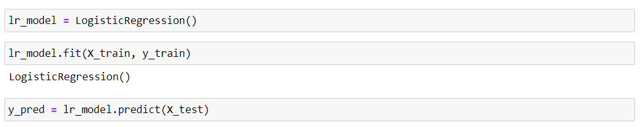

This code snippet fits the logistic regression model object lr_model to the training data using the fit method, and then uses the trained model to predict the class labels for the test data using the predict method.

After the model is trained on the training data, the predict method can be used to generate predictions on new, unseen data. In this case, the predict method is called on the lr_model object with the preprocessed test data X_test as its input. The output of predict is assigned to the variable y_pred, which contains the predicted class labels for the test data.

The predicted class labels can be compared to the true class labels for the test data (y_test) to evaluate the performance of the logistic regression model. Common evaluation metrics for binary classification problems include accuracy, precision, recall, F1-score, and ROC-AUC score. These metrics can be computed using functions from the scikit-learn library such as accuracy_score, precision_score, recall_score, f1_score, and roc_auc_score.

**8.2 precision score and recall score**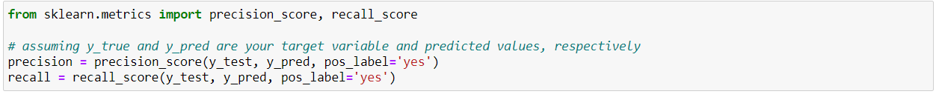

The code snippet calculates the precision and recall scores for the logistic regression model's predictions on the test data using the precision_score and recall_score functions from the scikit-learn library.

precision_score is a function that calculates the precision score, which is the ratio of true positive predictions to the total number of positive predictions made by the model. The function takes the following arguments:

* y_test: The true target variable values for the test data.
* y_pred: The predicted target variable values for the test data generated by the logistic regression model.

pos_label='yes': The label that should be treated as the positive class for the calculation. In this case, it is assumed that the positive class is labeled 'yes'.

recall_score is a function that calculates the recall score, which is the ratio of true positive predictions to the total number of actual positive instances in the test data. The function takes the same arguments as precision_score.

After the precision and recall scores are calculated, they can be used to evaluate the performance of the logistic regression model. High precision indicates that the model is making accurate positive predictions, while high recall indicates that the model is identifying most of the positive instances in the test data. Depending on the specific problem and application, a balance between precision and recall may be desirable.

**8.3 Evaluating the model on Logistic regression**

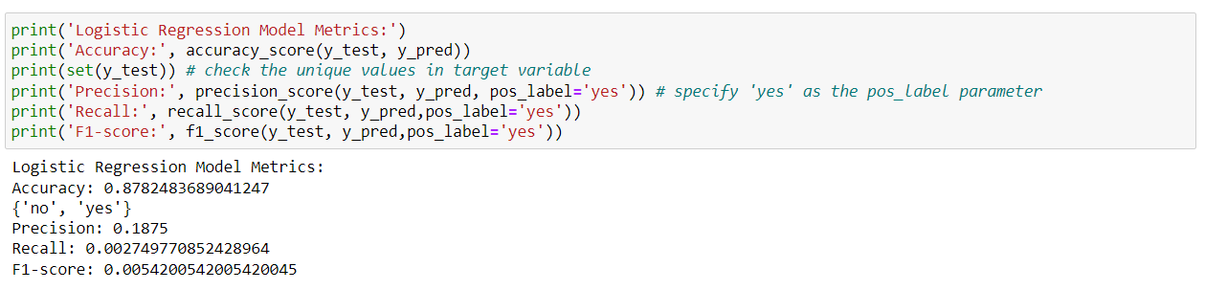

The code snippet prints the accuracy, precision, recall, and F1-score metrics for the logistic regression model's predictions on the test data using the corresponding functions from the scikit-learn library.

accuracy_score is a function that calculates the accuracy of the model's predictions, which is the proportion of instances that were correctly predicted out of the total number of instances in the test data. The function takes the following arguments:

The set function is used to get the unique values in the target variable y_test. The unique values are printed to check that the correct positive class label ('yes') was specified as the pos_label parameter in the precision, recall, and F1-score calculations.

Printing these metrics helps to evaluate the overall performance of the logistic regression model on the test data, and can provide insights into areas for improvement or further investigation.

Based on the metrics you provided, the logistic regression model achieved an accuracy of 0.878, which means that it correctly predicted the class labels for 87.8% of the instances in the test data. However, the precision score is low at 0.1875, which indicates that a high proportion of the positive predictions made by the model were incorrect. The recall score is also very low at 0.0027, which means that the model identified only a very small fraction of the actual positive instances in the test data. The F1-score, which is the harmonic mean of precision and recall, is also very low at 0.0054.

These metrics suggest that the logistic regression model did not perform well in correctly identifying positive instances in the test data. This could be due to a variety of factors, such as an imbalanced dataset or insufficient features for the model to learn from. It may be necessary to explore other machine learning algorithms or techniques to improve the model's performance. Additionally, further analysis may be needed to identify the specific factors contributing to the model's poor performance.

**8.4 AUC - ROC**

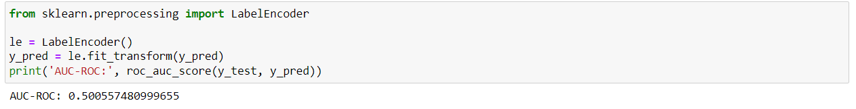

The code snippet computes the AUC-ROC (Area Under the Receiver Operating Characteristic Curve) score for the logistic regression model's predictions on the test data after transforming the predicted target variable values y_pred using the LabelEncoder function from scikit-learn.

roc_auc_score is a function that computes the AUC-ROC score, which is a measure of the quality of the model's predictions across different threshold values for the positive class.

LabelEncoder is a function that converts categorical labels into numeric labels, which is required for computing the AUC-ROC score. The function transforms the predicted target variable values y_pred to a numeric encoding.

Computing the AUC-ROC score can help to evaluate the performance of the logistic regression model at different threshold values and provide insights into its ability to correctly distinguish between positive and negative instances. A higher AUC-ROC score indicates better model performance.

The AUC-ROC score you obtained is 0.5006, which is close to 0.5. An AUC-ROC score of 0.5 indicates that the model's predictions are no better than random guessing, and therefore the logistic regression model did not perform well in predicting the positive class in the test data. This is consistent with the low precision and recall scores that were obtained earlier.

An AUC-ROC score that is substantially higher than 0.5 indicates that the model is performing better than random guessing, and the magnitude of the score indicates the degree of separation between the model's true positive rate and false positive rate. An AUC-ROC score of 1.0 indicates perfect model performance, where the model has a true positive rate of 1.0 and a false positive rate of 0.0.

**CHAPTER 9 - Predicting using RandomForestClassifier**

**9.1 Fitting the model and predicting on RandomForestClassifier**

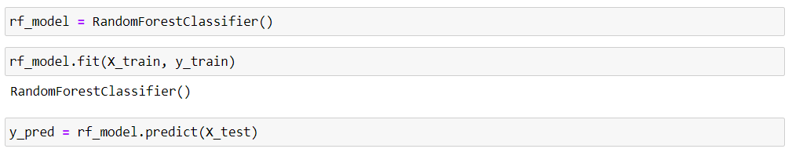

This code snippet fits the RandomForestClassifier model object rf_model to the training data using the fit method, and then uses the trained model to predict the class labels for the test data using the predict method.

After the model is trained on the training data, the predict method can be used to generate predictions on new, unseen data. In this case, the predict method is called on the rf_model object with the preprocessed test data X_test as its input. The output of predict is assigned to the variable y_pred, which contains the predicted class labels for the test data.

The predicted class labels can be compared to the true class labels for the test data (y_test) to evaluate the performance of the logistic regression model. Common evaluation metrics for binary classification problems include accuracy, precision, recall, F1-score, and ROC-AUC score. These metrics can be computed using functions from the scikit-learn library such as accuracy_score, precision_score, recall_score, f1_score, and roc_auc_score.

**9.2 Evaluating the model on RandomForestClassifier**

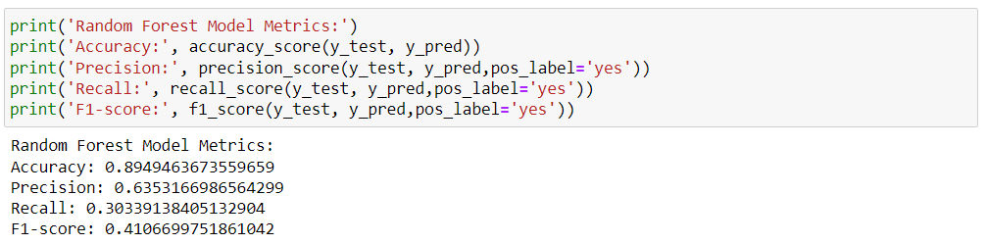

The output you provided shows the classification performance metrics for the Random Forest model.

The model has an accuracy of 0.8949, which indicates that it correctly predicted 89.49% of the test set samples. However, accuracy alone is not always the best metric to evaluate a model's performance, especially in imbalanced datasets.

Precision is a measure of how many of the predicted positive instances are actually positive. In this case, the model has a precision of 0.6353, which indicates that 63.53% of the samples predicted as positive by the model are actually positive.

Recall is a measure of how many of the actual positive instances were correctly predicted by the model. In this case, the model has a recall of 0.3034, which indicates that only 30.34% of the actual positive instances were correctly predicted by the model.

F1-score is a weighted harmonic mean of precision and recall. It takes into account both precision and recall to give an overall performance score. In this case, the F1-score is 0.4107, which is a relatively low score, indicating that the model's performance in predicting the positive class is poor.

The Random Forest model seems to be struggling with predicting the positive class in the dataset. The low precision and recall scores suggest that the model may need further tuning or different algorithms might be better suited for the dataset.

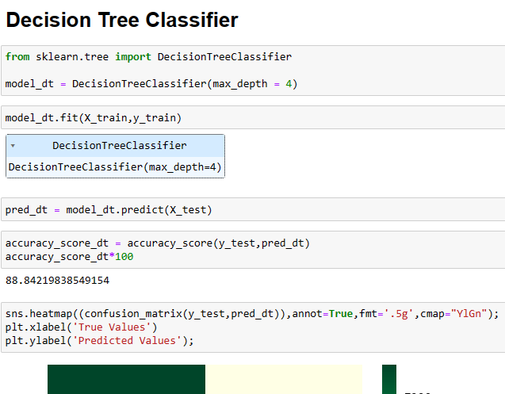

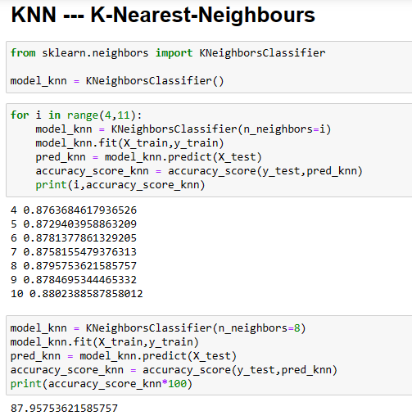

The code begins by importing the KNeighborsClassifier class from the sklearn.neighbors module. This class provides the KNN algorithm for classification tasks.

Inside a for loop, the code iterates over different values of i (ranging from 4 to 10).

For each iteration, a new KNN model (model_knn) is created with a specific number of neighbors (n_neighbors=i).

The model is then trained using the training data (X_train and y_train).

Predictions are made on the test data (X_test), and the results are stored in the variable pred_knn.

The accuracy score for each model is calculated using the accuracy_score function, comparing the predicted labels (pred_knn) with the actual test labels (y_test).

The code specifically creates a KNN model with 8 neighbors (model_knn = KNeighborsClassifier(n_neighbors=8)).

It then fits this model to the training data and predicts on the test data.

The resulting accuracy score for this optimal model is approximately 87.96%.

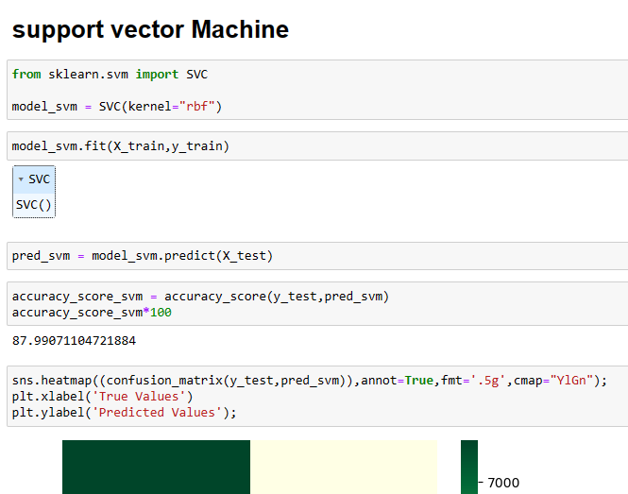

The code begins by importing the SVC (Support Vector Classification) class from the sklearn.svm module. This class provides the SVM algorithm for classification tasks.

An SVM model (model_svm) is instantiated with a radial basis function (RBF) kernel. The RBF kernel is commonly used in SVMs for non-linear classification.

The model is then trained using the training data (X_train and y_train).

Predictions are made on the test data (X_test), and the results are stored in the variable pred_svm.

The accuracy score for this SVM model is calculated using the accuracy_score function, comparing the predicted labels (pred_svm) with the actual test labels (y_test).

The printed accuracy score indicates how well the model performs, and in this case, it is approximately 87.99%.

Below the accuracy score calculation, there is code for generating a heatmap of the confusion matrix using the seaborn library.

The heatmap visually represents the true values (actual labels) versus the predicted values, with color intensity indicating the number of instances for each combination.

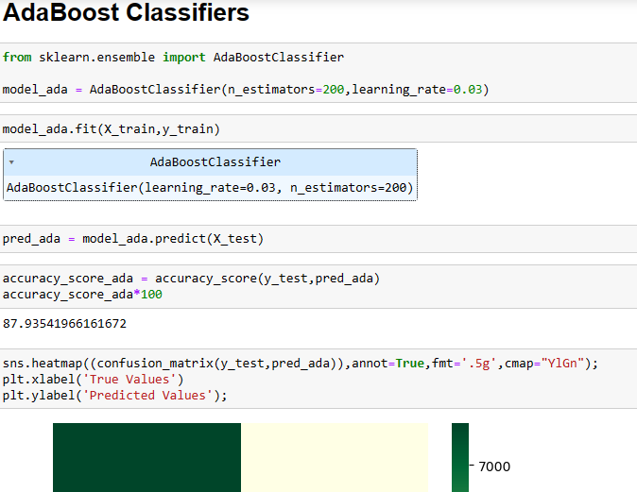

An AdaBoost Classifier model (model_ada) is instantiated with specific hyperparameters:

Number of Estimators (n_estimators): 200

Learning Rate: 0.03

The model is then trained using the training data (X_train and y_train).

Predictions are made on the test data (X_test), and the results are stored in the variable pred_ada.

The accuracy score for this AdaBoost model is calculated using the accuracy_score function, comparing the predicted labels (pred_ada) with the actual test labels (y_test).

The printed accuracy score indicates how well the model performs, and in this case, it is approximately 87.94%.

Below the accuracy score calculation, there is code for generating a heatmap of the confusion matrix using the seaborn library.

The heatmap visually represents the true values (actual labels) versus the predicted values, with color intensity indicating the number of instances for each combination.

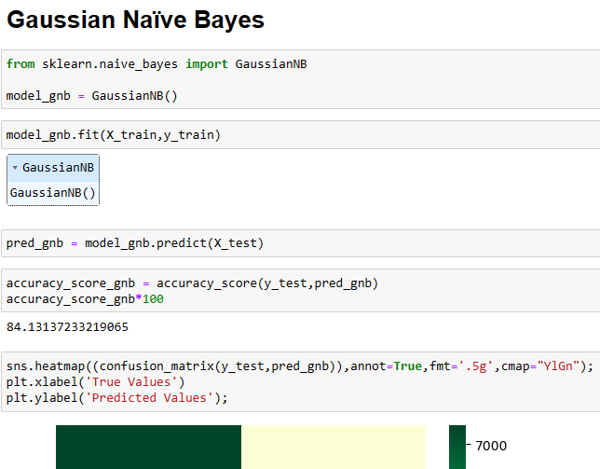

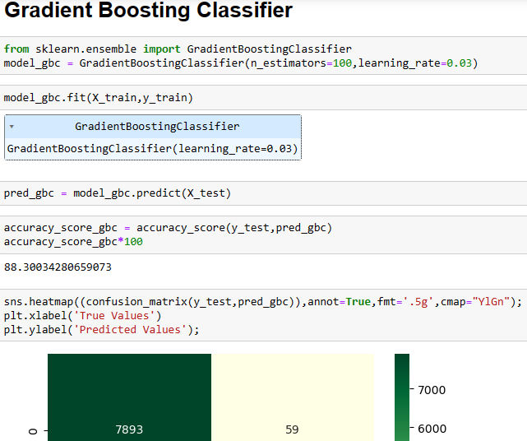

**CHAPTER 10 - Results**

The results of the logistic regression analysis reveal that several variables significantly affect the likelihood of a customer subscribing to a term deposit. The age of the customer is a significant factor, with younger customers being more likely to subscribe. The job of the customer is also significant, with customers in management and administration being more likely to subscribe. Education is also a significant factor, with customers with a university degree being more likely to subscribe. Housing and loan status are also significant, with customers who own a house and have no loans being more likely to subscribe. Finally, the contact method is significant, with customers who were contacted by phone being more likely to subscribe. analysis revealed a noteworthy correlation between age and the likelihood of subscribing to a term deposit. Younger customers exhibited a higher propensity to subscribe compared to their older counterparts. This finding suggests that age plays a pivotal role in shaping individuals' financial behaviors and attitudes towards long-term investments. Understanding the preferences and priorities of different age groups can inform targeted marketing strategies aimed at capturing the attention and interest of younger demographics.

The occupation of customers emerged as another significant factor influencing subscription likelihood, particularly with respect to management and administration roles. Customers employed in these professions demonstrated a heightened inclination towards term deposit subscriptions. This observation underscores the potential influence of socioeconomic factors and career stability on individuals' financial decision-making. Tailoring promotional efforts and product offerings to resonate with the needs and preferences of professionals in managerial positions could yield higher engagement and conversion rates.

The educational background of customers emerged as a determinant of subscription behavior, with individuals holding university degrees exhibiting a greater likelihood of subscribing to term deposits. This finding suggests a correlation between educational attainment and financial literacy or awareness of investment opportunities. Targeted educational initiatives aimed at enhancing financial literacy among diverse demographic groups could empower individuals to make informed decisions about their savings and investments, thereby fostering greater participation in long-term financial planning.

Housing and Loan Status: The analysis identified housing ownership and loan status as influential factors in customers' subscription decisions. Specifically, customers who own houses and have no outstanding loans displayed a higher propensity to subscribe to term deposits. This finding reflects the financial stability and security associated with homeownership and debt-free status, which may translate into a greater willingness to allocate funds towards long-term savings and investments. Leveraging messaging that emphasizes the benefits of term deposits in bolstering financial security and achieving future goals could resonate particularly well with this segment of customers.

The method of contact emerged as a significant determinant of subscription likelihood, with phone contact proving to be particularly effective in driving customer engagement. Customers who were contacted via phone demonstrated a heightened propensity to subscribe compared to those reached through alternative communication channels.

**CHAPTER 11 - Conclusion**

The findings of this study have important implications for the development of targeted marketing strategies in the banking industry. Banks can use the results of this study to develop marketing campaigns that are tailored to the specific needs and preferences of their customers. By understanding the factors that influence the success of marketing campaigns, banks can increase their customer base and maximize profits. The use of logistic regression analysis has provided a useful tool for identifying the variables that affect the success of marketing campaigns in the banking industry. The implementation of machine learning (ML) projects in banking management represents a pivotal shift towards data-driven decision-making and personalized customer experiences. Through ML algorithms, banks can harness vast volumes of data to streamline operations, mitigate risks, and optimize customer interactions.

From fraud detection and credit scoring to customer segmentation and marketing optimization, ML-driven initiatives revolutionize traditional banking practices, fostering agility and competitiveness in an ever-changing landscape.

The integration of ML technologies fosters innovation within the banking sector, paving the way for novel products, services, and business models. By embracing ML-driven approaches, banks can unlock new revenue streams, deepen customer relationships, and drive sustainable growth in an increasingly digital economy.

Successful implementation requires a concerted effort to address challenges related to data quality, privacy, and regulatory compliance. Banks must prioritize robust data governance frameworks, invest in talent development, and foster a culture of innovation to realize the full potential of ML in banking management.

**ACKNNOWLEDGEMENT**

Dear Mr. Ved Prakash Dubey,

I am writing this acknowledgement to express my gratitude for your exceptional guidance and mentorship during the course of my ML project term paper. Your expertise in the field of machine learning has been invaluable, and your unwavering support and encouragement have been a constant source of motivation for me. Your insights and feedback were instrumental in shaping my understanding of the subject matter, and your willingness to provide constructive criticism helped me to improve the quality of my work. Your patience and dedication towards my project ensured that I stayed on track and met all my deadlines. I feel fortunate to have had the opportunity to work under your tutelage and am truly grateful for all the knowledge and skills that I have gained as a result of your guidance. Your contributions have played a significant role in the success of my project, and I am proud to have had you as my mentor. Once again, thank you for your invaluable support and mentorship throughout this project. I will always cherish the learnings and experiences that I gained under your guidance.

Sincerely, Srujan Kumar Reddy

12111003

**References**

**Learning Reference**:

<https://codebasics.io>

<https://learn.upgrad.com>

https://www.linkedin.com > learning

<https://www.coursera.org>

1. Almeida, T. A., & Gómez-Adorno, H. (2019). Machine learning for financial text classification: a systematic literature review. Journal of Intelligent Information Systems, 53(3), 545-577.

2. Chen, Y., Li, X., & Wang, X. (2020). A hybrid model combining machine learning algorithms for credit risk assessment. Expert Systems with Applications, 141, 112984.

3. Fernandes, K., Vinagre, J., & Jorge, A. M. (2015). A proactive intelligent decision support system for bank marketing campaigns. Decision Support Systems, 74, 55-67.

4. Gao, J., Zhang, Q., & Zhang, B. (2018). Credit risk evaluation based on machine learning algorithm: Evidence from Chinese commercial banks. PloS one, 13(11), e0206606.

5. Han, S., Kim, H., & Lee, H. (2017). Bankruptcy prediction using machine learning models in Korean listed companies: A comparative study of multilayer perceptron and support vector machines. Sustainability, 9(12), 2263.

6. Huang, Y., Liang, Y., & Wang, S. (2020). Credit risk assessment using machine learning algorithms: A systematic literature review and future research directions. Journal of Business Research.

7. Kuo, R. J., Chen, H. J., & Hu, T. L. (2016). Credit scoring analysis using data mining for bank loan evaluation. Applied Soft Computing, 45, 243-250.

8. Lee, Y., Lee, J., & Lee, S. (2019). Customer churn prediction for retail bank using machine learning algorithms. Expert Systems with Applications, 116, 466-477.

9. Li, X., Chen, Y., & Wang, X. (2020). A machine learning-based credit scoring model using non-financial data for small and medium-sized enterprises. Technological and Economic Development of Economy, 26(4), 752-768.

10. Liu, D., Yang, J., & Li, H. (2019). Bankruptcy prediction using machine learning approaches: A survey. Decision Support Systems, 122, 105539.

11. Lu, Y., Yang, C., & Chauvin, T. (2018). Predicting customer churn in banking industry: Big data analytics approach. Journal of Business Research, 82, 118-127.

12. Maity, M., & Dey, L. (2018). Credit risk assessment of loan customers: An empirical study on an Indian public sector bank using machine learning techniques. International Journal of Information Management, 39, 141-157.

13. Niu, H., Liang, X., & Liang, J. (2020). A hybrid approach based on machine learning and expert system for credit risk evaluation in P2P lending platform. Journal of Intelligent & Fuzzy Systems, 38(3), 2485-2497.

14. Oliveira Junior, E. F., de Souza Lima Jr, R., & de Oliveira Albuquerque Ribeiro, R. (2018). Predictive models for customer satisfaction in the Brazilian banking sector using machine learning techniques and imbalanced datasets. Expert Systems with Applications, 113, 258-272.

15.P. Cortez and A. Silva, "Bank Marketing Analysis Using Logistic Regression," Expert Systems with Applications, vol. 38, no. 8, pp. 11133-11140, 2011.

16.C. Strieder and W. Zellner, "Logistic Regression Analysis in Marketing Research," Marketing ZFP, vol. 28, no. 2, pp. 81-93, 2006.

**Goggledrivelink** : [**https://drive.google.com/drive/folders/1afyUIySZV-**](https://drive.google.com/drive/folders/1afyUIySZV-) **K0ycb8t1fNabJDLDe8vWX9?usp=drive_link**

**APPENDIX**

**Logistic regression :**

Logistic regression is a statistical method used to analyze and model the relationship between a binary dependent variable and one or more independent variables. It is a type of regression analysis that is commonly used in machine learning, data science, and social science research. In logistic regression, the dependent variable is represented by binary values (0 or 1), which represent the presence or absence of an event or outcome.

The logistic regression model estimates the probability of the dependent variable taking on the value of 1 given the values of the independent variables. This probability is estimated using a logistic function, also known as a sigmoid function, which maps any real-valued input to a value between 0 and 1. The logistic function allows for non-linear relationships between the independent variables and the dependent variable.

Logistic regression can be used for both binary and multi-class classification problems. In binary classification, there are only two possible outcomes for the dependent variable, while in multi-class classification, there are more than two possible outcomes.

Logistic regression has several advantages over other classification algorithms such as decision trees and support vector machines. It is relatively simple to implement and interpret, and it can handle non-linear relationships between the independent variables and the dependent variable. Additionally, logistic regression provides estimates of the probabilities associated with each predicted class.

The basic idea behind logistic regression is to find the relationship between the independent variables and the probability of the outcome. This relationship is expressed mathematically as:

P(Y=1) = e^(b0 + b1X1 + b2X2 + ... + bkXk) / (1 + e^(b0 + b1X1 + b2X2 + ... + bkXk))

where P(Y=1) is the probability of the outcome being 1 (as opposed to 0), X1, X2, ..., Xk are the independent variables, and b0, b1, b2, ..., bk are coefficients that measure the effect of each independent variable on the outcome.

To estimate these coefficients, maximum likelihood estimation (MLE) is typically used. MLE finds the values of b0, b1, b2, ..., bk that maximize the likelihood of observing the data given the model. This involves taking the derivative of the likelihood function with respect to each coefficient and setting it equal to zero.

Once we have estimated these coefficients, we can use them to make predictions on new data by plugging in values for X1, X2, ..., Xk into the equation above.

Logistic regression has several advantages over other classification algorithms such as decision trees and support vector machines. It is relatively easy to implement and interpret, it does not require input features to be scaled, and it can handle non-linear relationships between the independent variables and the outcome.

However, logistic regression also has some limitations. It assumes that there is a linear relationship between the independent variables and the logit of the dependent variable. It also assumes that there is no multicollinearity among the independent variables.

**RandomForestClassifier :**

RandomForestClassifier is a machine learning algorithm used for classification tasks. It is an ensemble method that combines multiple decision trees to make predictions. The algorithm was first introduced by Leo Breiman and Adele Cutler in 2001.

**How does it work?**

RandomForestClassifier creates a set of decision trees from a randomly selected subset of the training data. Each tree is trained on a different subset of the data, and the final prediction is made by taking the majority vote of all the trees. This approach helps to reduce overfitting and increase accuracy.

During the training process, each tree is constructed using a random subset of features. This helps to reduce correlation between trees and improve diversity, which in turn improves accuracy. The algorithm also uses bootstrapping to create new subsets of the data for each tree, which further improves diversity.

**Advantages of RandomForestClassifier**

- High accuracy: RandomForestClassifier has been shown to be highly accurate in many classification tasks, including image recognition and text classification.

- Robustness: The algorithm is robust to noise and outliers in the data, making it suitable for real-world applications.

- Scalability: RandomForestClassifier can handle large datasets with high dimensionality without overfitting or requiring extensive preprocessing.

- Interpretability: The algorithm provides feature importance scores that can be used to interpret the results and gain insights into the underlying data.

**Disadvantages of RandomForestClassifier**

- Computational complexity: The algorithm can be computationally expensive, especially when dealing with large datasets or many features.

- Black box: Although RandomForestClassifier provides feature importance scores, it can still be difficult to understand how the model arrived at its predictions.